Nama : Samuel Arie Rasmadi

NIM : 22.01.53.0053

Mata Kuliah : Web Service

Tugas Menambah Data Customers

Perintah :

POST <https://img.adhi-info.com/api/api.php/records/customers>

{

    "company": "Company JJ",

    "last_name": "Arie",

    "first_name": "Samuel",

    "email_address": "samuel@gmail.com",

    "job_title": "Manager",

    "business_phone": "085678992222",

    "home_phone": "(123)555-0102",

    "mobile_phone": "0978773456",

    "fax_number": "",

    "address": "jalan kendeng",

    "city": "Semarang",

    "state_province": "Jawa Tengah",

    "zip_postal_code": "50066",

    "country_region": "INDONESIA",

    "web_page": "",

    "notes": "",

    "attachments": ""

}

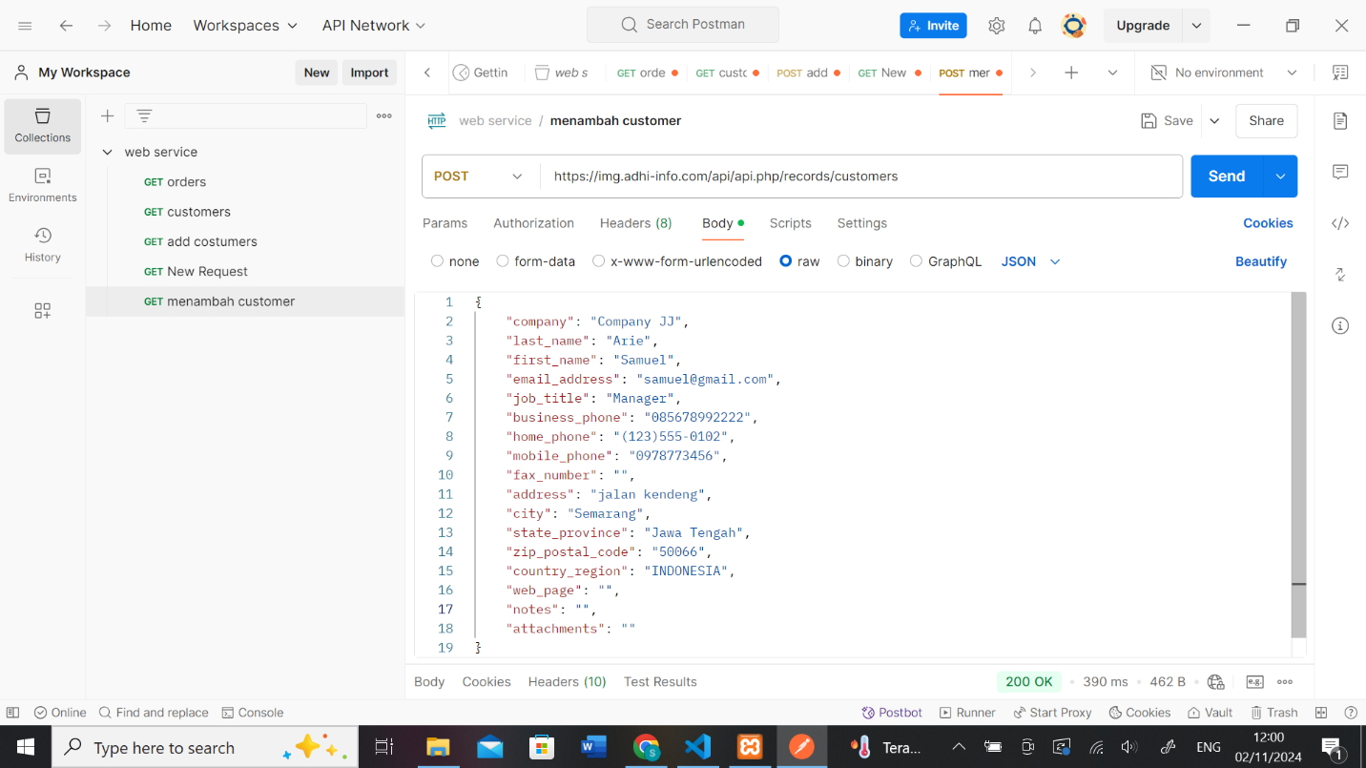

HASIL :

